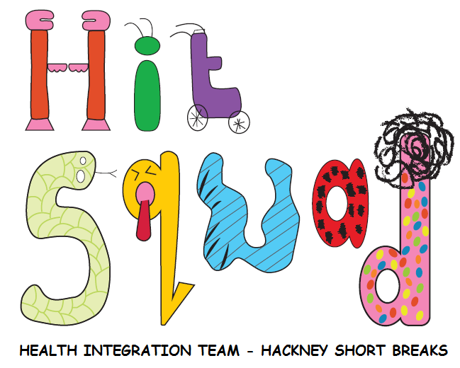
REFERRAL TO THE HIT SQUAD
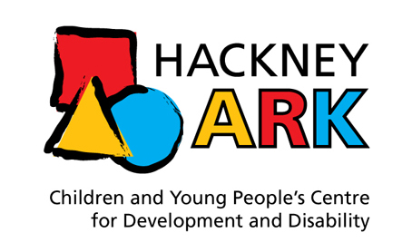

What can we do?
1) LEISURE PROVIDER TRAINING REQUESTS: We offer training to any leisure providers in Hackney to improve access for all children/young people with additional needs.
2) INDIVIDUAL CHILD/YOUNG PERSON REFERRALS: We can also provide support to any child/young person known to the Short Breaks team. We aim to work together to meet the child/young person’s specific physical, behavioural, sensory or communication needs if they are having difficulty accessing the leisure activity of their choice.
The HIT squad works alongside the Short Breaks service.

LEISURE PROVIDER TRAINING REQUEST
The HIT squad run centralised and bespoke trainings based on the needs of leisure providers.

Please outline the specific training needs of your service:
Please outline any recent training your service has already had:
Please state the outcome that you would like from training from us:
Please give rough dates/times for training sessions that will work best for your setting

INDIVIDUAL CHILD/YOUNG PERSON REFERRAL

Is the child/young person known to the Short Breaks team? You can check by calling the Short Breaks Administrator on  020 8356 6789. | NO We cannot accept a referral for individual work until the child/young person is accepted for Short Breaks. Please complete a Short Breaks Referral form and email to short.breaks@hackney.gov.uk  YES
Date of referral to HIT squad:
Child/young person’s name:
Address:

Telephone number: |  |  | Gender:
Date of Birth: |  |  | Ethnic Code:
NHS number (if known): |  |  | Religion (if known):
Other services/professionals known to be involved with the young person:
Have parents consented to this referral to the HIT squad? |  | Yes No If not, please do so before completing  the rest of the form. We will need to telephone all parents to check consent before proceeding with the referral.

Parents/Carers/Guardians:

Carer’s/parent’s names:
Address (if different from child/YP):
Tel No.:
Language Spoken:
Interpreter Required: | Yes No

School/College:

Name and
Address:
Tel No.:

Reason for referral:

What activities do you think the child/young person would like help to access?
What appears to be getting in the way of them accessing these activities?
(e.g. child struggles in large groups at playgroup):
Known diagnoses or medical conditions (e.g. mobility, communication, visual/hearing impairment etc.):
How do you think the HIT squad could help?

Referrer:

Name of person making the referral:
Relationship to the child:
Contact address and telephone number:

Please send the completed form to:
- Internal referrals - email: huh-tr.hitsquad@nhs.net
- External referrals - post:

The HIT squad, Hackney Ark, Downs Park Road, E8 2FP (0207 014 7025)

