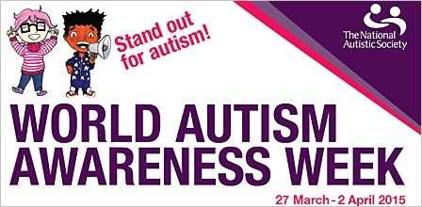
Video links | Title | Notes
https://www.ambitiousaboutautism.org.uk/what-we-do/awareness/world-autism-awareness-week-2021 | Ambitious about Autism  Young people explain their experiences of autism.
https://youtu.be/buNpQREv-Ms | World Autism Awareness Week: Primary school learning resources  5 good rules.
https://youtu.be/98gcyN9MdHU | World Autism Awareness Week: Primary school learning resources  Meet the Trummies!
https://youtu.be/p1pONE9SmDY | World Autism Awareness Week: Secondary school learning resources  Talia Grant introduces this powerful film about Alex who is autistic and some of the challenges he faces on a daily basis.
https://youtu.be/1CLAR56Pk5o | World Autism Awareness Week: Secondary school learning resources  Talia Grant, who is autistic, talks about what it was like to be a young autistic person at school.

