[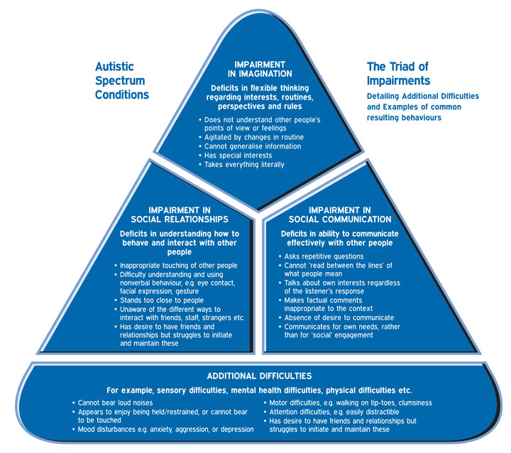](http://www.google.co.uk/url?sa=i&rct=j&q=autism+triad+of+impairment&source=images&cd=&cad=rja&docid=cbwRJus7ZzLtkM&tbnid=6rg9glTjicMLGM:&ved=0CAUQjRw&url=http://www.brookdalecare.co.uk/what-is-autism&ei=cKgYUZTwO6mw0AX-g4H4Dw&psig=AFQjCNHutwcxVUz5XFvbucxX2CYbP8iGtg&ust=1360656864624384)