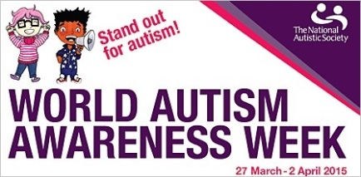
finish time | activity
3.45 | Autism Awareness Flashcards 10 minutes (resources - 9 laminated cards in pack, hyperlink: V:\Training\Autism Awareness Week March-April 2021\2. Autism Awarenss Flashcards.pdf)  Deal out flashcards amongst colleagues. Take turns to read out Fact or Myth statement, opportunity for brief discussion about statement, then share answer on reverse of flashcard.
3.50 | Autism Awareness Quiz 15 minutes (resources - Question and Answer Booklet and mystery prize in pack, hyperlink: V:\Training\Autism Awareness Week March-April 2021\3. Quiz.pdf)  Nominate Quizmaster to ask questions (this person needn’t be the teacher). Remainder of colleagues split into 2 teams. Quizmaster asks questions and teams write down answers. The winning team wins a mystery prize!!! We trust colleagues to be honest when self-marking …  You will need paper and pens for each team.
3.55 | Autism Awareness videos 20 minutes (resources - sheet to record comments in pack, hyperlink: V:\Training\Autism Awareness Week March-April 2021\4. Autism Awareness video links.docx)  Watch the 5 short videos. Offer colleagues an opportunity to comment after each clip. Record any comments for further discussion at class meeting.
4.00 | Autism Awareness PowerPoint 25 minutes (resources – printed version of presentation, hyperlink: V:\Training\Autism Awareness Week March-April 2021\5. Autism Awareness @ Ickburgh presentation.pptx)  The teacher delivers the presentation. After each slide the team is given an opportunity to comment on the implications for their pupils, i.e. “the majority of our pupils are sensitive to noise … how can we lessen adult talk and background noise … “

Hyperlink to this document: V:\Training\Autism Awareness Week March-April 2021\1. Activity guidance sheet.docx

