Ickburgh School
Primary Age Phase

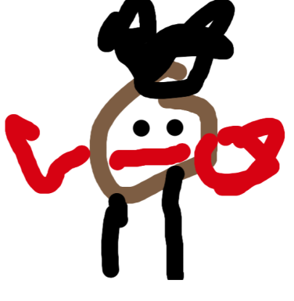
We would like to invite all parents of primary pupils to our Countryside assembly to show you some of the work we have done this term.

Day: Monday 17th July 2017
Time: 10.45am
Place: Ickburgh School Atrium

There will be a coffee morning for all parents at 9.30am also on that morning

We look forward to seeing you here

