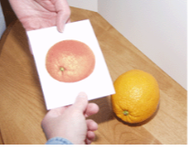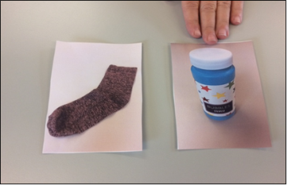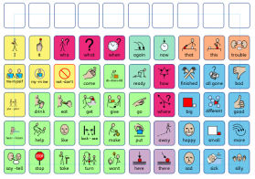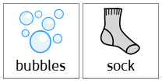

**Symbolic understanding** means at what level the child understands symbols (e.g. do they understand that a photograph is representing something or it is just a fun piece of laminated paper).

Every child’s symbolic understanding is assessed by the Speech and Language Therapists (SaLTs). On the **MDT checklist** it says whether the child understands objects/photos/symbols.

Look at the MDT checklist to see what level each child is at. **Once a term try to ‘test’ the child** to see whether anything has changed. Use this flow chart to help you. If something has changed, then **contact your SaLT** to think about next steps.

Make sure you have some **photographs and symbols ready** that match the motivating and non-motivating items you have chosen for that child.

**Symbolic Understanding Decision Making Tree**